**МИНОБРНАУКИ РОССИИ**

**Санкт-Петербургский государственный**

**электротехнический университет**

**«ЛЭТИ» им. В.И. Ульянова (Ленина)**

**Кафедра САПР**

Курсовая РАБОТА

**по дисциплине «Программирование»**

|  |  |  |
| --- | --- | --- |
| Студент гр. 1302 |  | Новиков Г.В. |
| Преподаватель |  | Калмычков В.А |

Санкт-Петербург

2022

**ЗАДАНИЕ**

**на курсовую работу**

|  |  |  |
| --- | --- | --- |
| Студент: Новиков Г.В. | | |
| Группа 1302 | | |
| Исходные данные: Текст, представляющий собой последовательность строк, длина каждой из которых не превышает некоторого задаваемого при выполнении значения, вводится с клавиатуры или из файла.  Необходимо: преобразовать текст в соответствии с последовательностью команд редактирования, которые должны позволять вставлять, удалять и заменять заданные слова и подстроки | | |
| Содержание пояснительной записки: цель курсовой работы, исходная постановка, способы реализации ввода-вывода, написанные функции, разбиение программы на файлы, алгоритмы и структуры данных, текст программы, тестирование программы, вывод. | | |
| Дата выдачи задания: | | |
| Дата сдачи реферата: | | |
| Дата защиты реферата: | | |
| Студент |  | Новиков Г.В. |
| Преподаватель |  | Калмычков В.А |

**Аннотация**

В работе представлена программа, решающая поставленную задачу по редактированию заданного текста. Входные данные представляют собой либо файл, либо введенный с клавиатуры текст. По команде пользователя осуществляется одна из операций: удаление, вставка или замена набора символов, определяемых понятиями контекста и номера текущей строки, а также вывод отредактированного текста на экран, переход между строками и запись результата в указываемый файл.

**Summary**

The paper presents a program that solves the task of editing a given text. The input data is either a file or text entered from the keyboard. At the user's command, one of the operations is performed: deletion, insertion or replacement of a set of characters defined by the concepts of the context and current line number, as well as displaying the edited text on the screen, switching between lines and writing the result to the specified file.

Оглавление

Цель курсовой работы: 5

Исходная постановка: 5

Способы реализации ввода-вывода 5

Написанные функции: 5

Разбиение программы на файлы 8

Алгоритмы и структуры данных 9

Текст программы 9

Тестирование программы 16

Вывод 18

# **Цель курсовой работы:**

Продемонстрировать умение хранить, обрабатывать текстовыми данными, представленные в виде связных списков

# Исходная постановка:

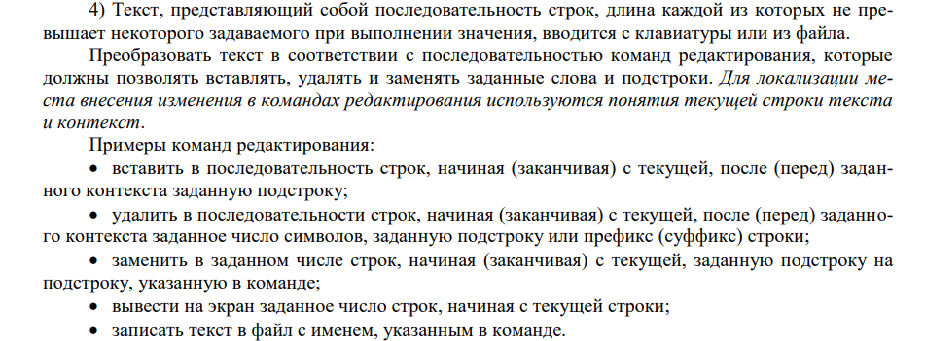

Способы реализации ввода-вывода:

|  |  |  |  |
| --- | --- | --- | --- |
|  | iostream | fstream | string |
| Ввод | cin | ios::in | getline |
| Вывод | cout | ios::out |  |

# **Написанные функции:**

|  |  |
| --- | --- |
| read, read_from_console | Ввод из файла или из консоли, создание классов |
| protocol | Ведение протокола |
| set_line_index | Установка текущей строки |
| print | Вывод строк в консоль |
| del | Удаление |
| ins | Вставка |
| replace | Замена |
| write | Запись в файл |
| out | Вывод в файл |
| clear_file | Удаление содержимого файла или создание нового |

**main:**

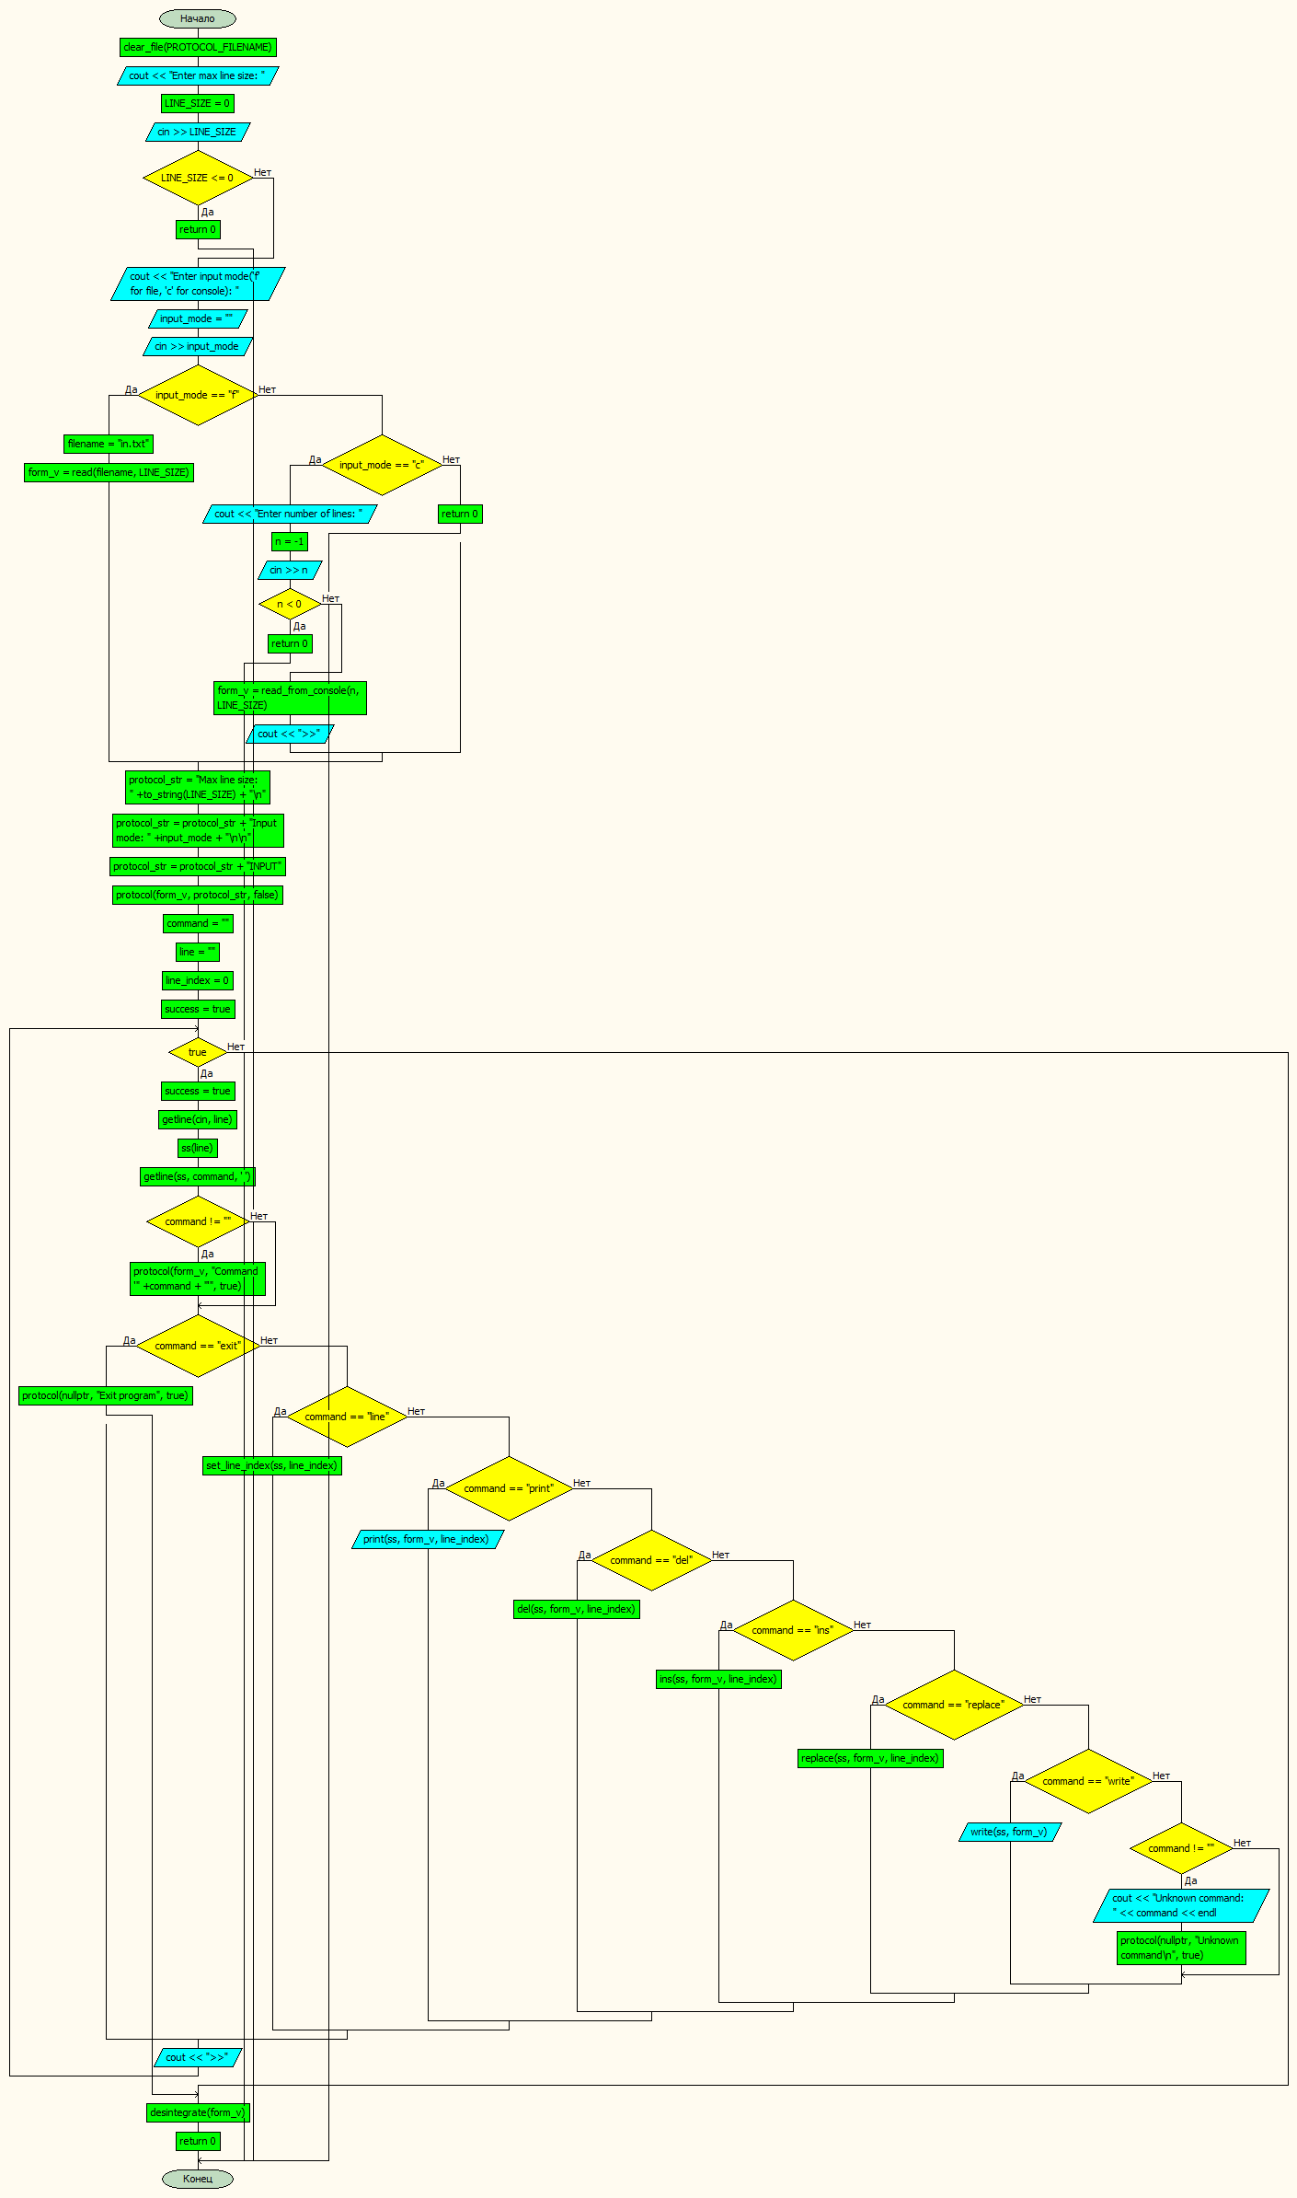

**set_line_index, print:**

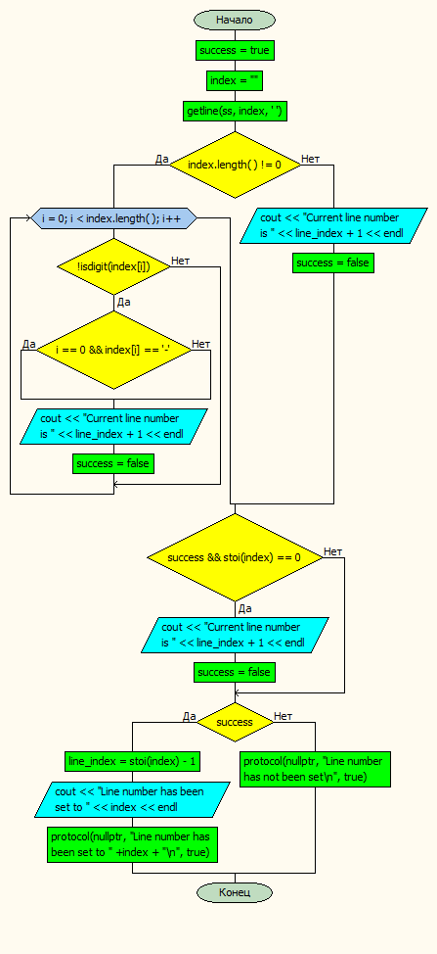 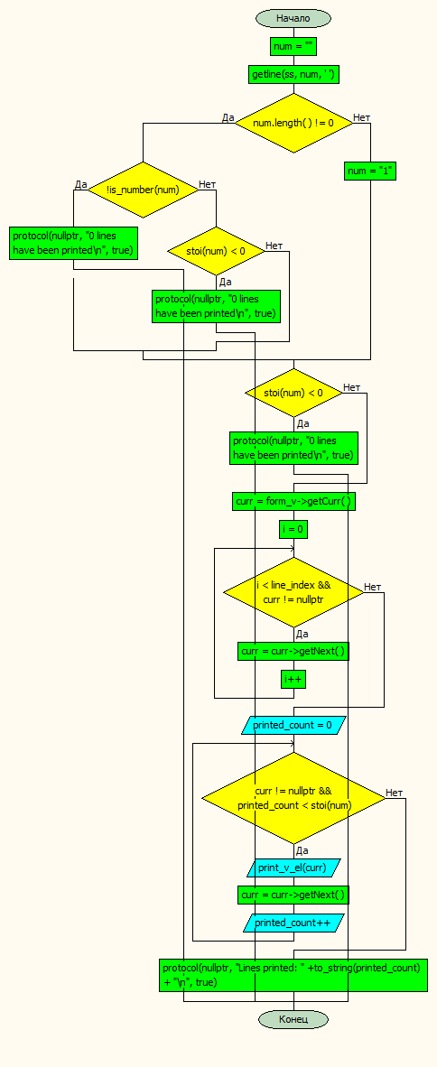

**del:**

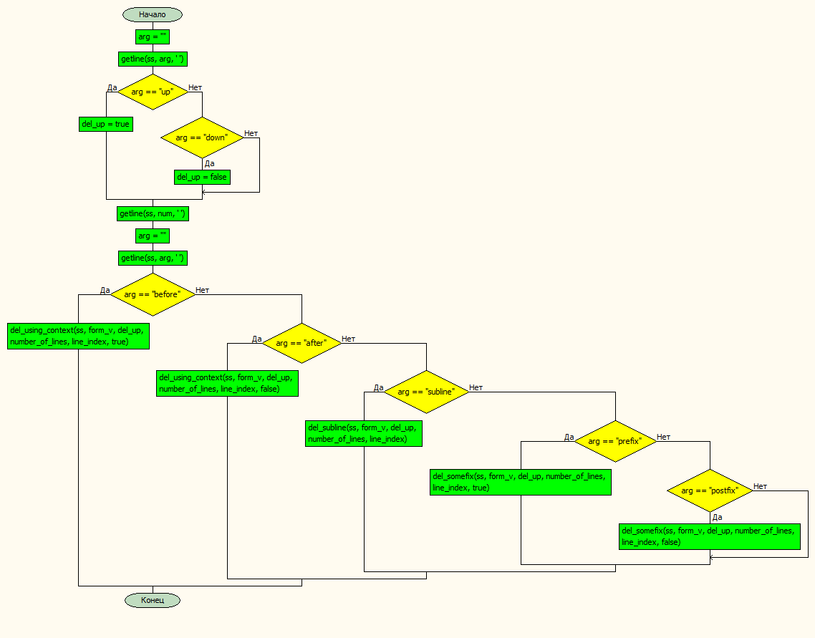

**replace, write, out:**

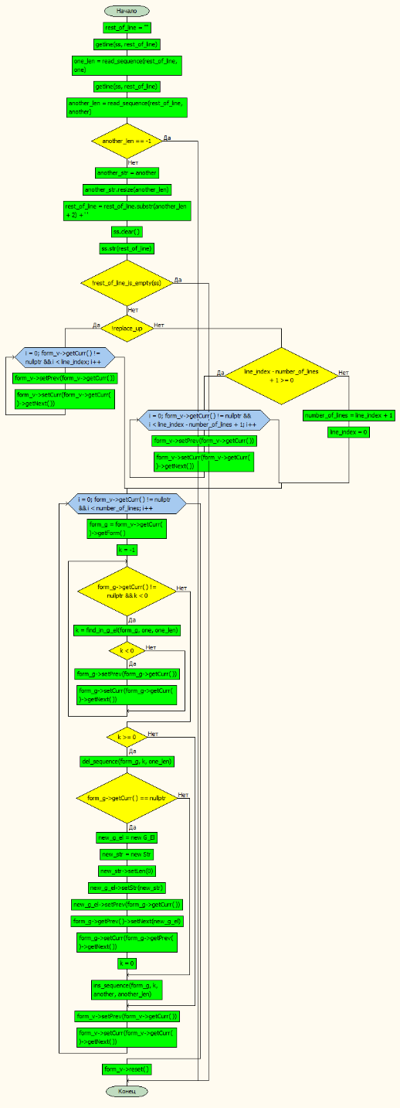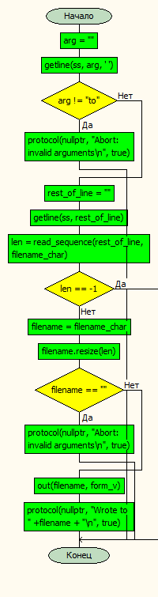 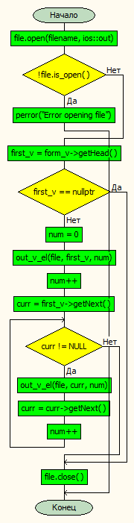

# 

# **Разбиение программы на файлы**

|  |  |
| --- | --- |
| main.cpp | Основа программы |
| read.h, read.cpp | Чтение из файла или из консоли |
| out.h, out.cpp | Вывод в файл |
| functions.h, functions.cpp | Функции обработки |
| FormV.h, FormV.cpp | Вертикальный формуляр |
| V_El.h, V_El.cpp | Вертикальный элемент |
| FormG.h, FormG.cpp | Горизонтальный формуляр |
| G_El.h, G_El.cpp | Горизонтальный элемент |
| Str.h, Str.cpp | Строка |
| in.txt | Ввод |
| out.txt | Вывод |
| protocol.txt | Протокол |

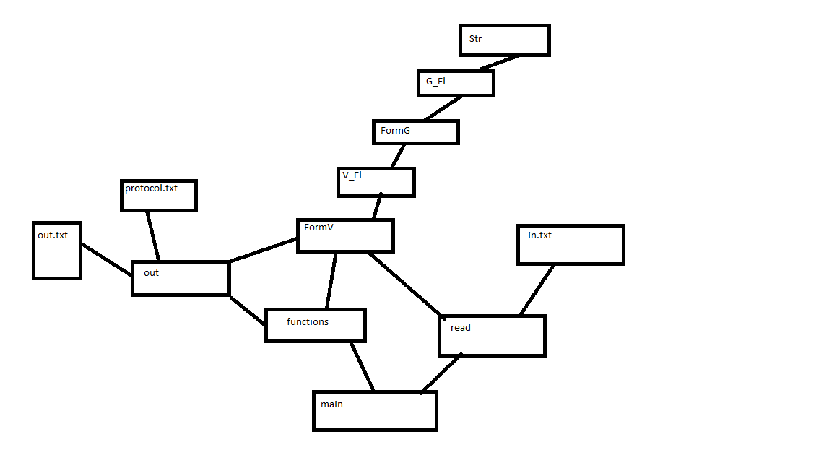

# Алгоритмы и структуры данных

**Список блоков символов:**

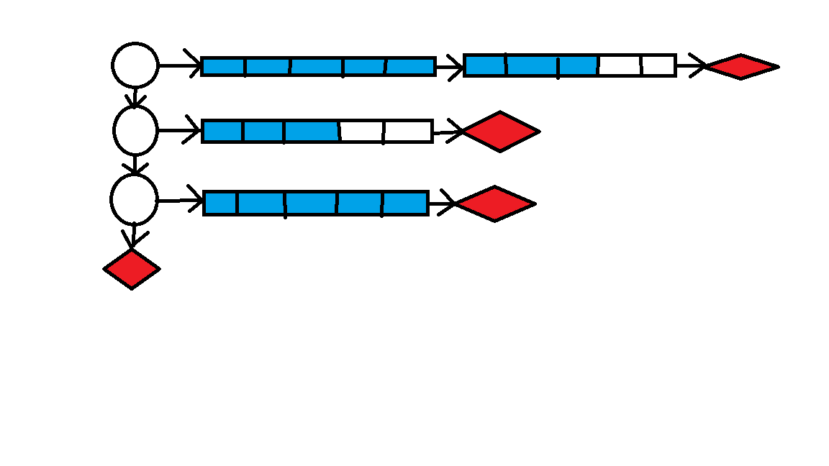

# Текст программы

Main.cpp

#include "functions.h"

#include "read.h"

// max_line_len from console DONE

// read from file DONE

// read from console DONE

// set current line(index of line) DONE

// exit DONE

// line DONE

// print DONE

// delete DONE

// insert DONE

// replace DONE

// write to file DONE

int main()

{

cout << "Author: Novikov G.V.\n"

"Start date: 06.06.2022\n"

"End date: 16.09.2022\n"

"Version: cursed.01\n" << endl;

clear_file(PROTOCOL_FILENAME);

cout << "Enter max line size: ";

int LINE_SIZE = 0;

cin >> LINE_SIZE;

if (LINE_SIZE <= 0) {

cerr << "Error: invalid line size" << endl;

return 0;

}

cout << "Enter input mode('f' for file, 'c' for console): ";

string input_mode = "";

cin >> input_mode;

FormV* form_v;

if (input_mode == "f") {

string filename = "in.txt";

form_v = read(filename, LINE_SIZE);

}

else if (input_mode == "c") {

cout << "Enter number of lines: ";

int n = -1;

cin >> n;

if (n < 0) {

cerr << "Error: number of lines cannot be < 0" << endl;

return 0;

}

form_v = read_from_console(n, LINE_SIZE);

cout << ">>";

}

else {

cerr << "Error: invalid input mode" << endl;

return 0;

}

string protocol_str = "Max line size: " + to_string(LINE_SIZE) + "\n";

protocol_str = protocol_str + "Input mode: " + input_mode + "\n\n";

protocol_str = protocol_str + "INPUT";

protocol(form_v, protocol_str, false);

string command = "";

string line = "";

int line_index = 0;

bool success = true;

while (true) {

success = true;

getline(cin, line);

stringstream ss(line);

getline(ss, command, ' ');

if (command != "") protocol(form_v, "Command '" + command + "'", true);

if (command == "exit") {

// exit - exit

protocol(nullptr, "Exit program", true);

break;

}

else if (command == "line") {

// line - print current line number

// line <int> - go to line

set_line_index(ss, line_index);

}

else if (command == "print") {

// print <int> - print given number of lines

print(ss, form_v, line_index);

}

else if (command == "del") {

// del down... - in lines starting with current 1

// del up... - in lines finishing with current 1

// del...after <string>... - after subtext |-------------->| 2

// del...before <string>... - before subtext |-------------->| 2

// del...subline "<string>" - subline | 2

// del...prefix <int> - first N symbols of line |------>| 2

// del...postfix <int> - last N symbols of line |------>| 2

// del...<int> symbols... - number of symbols |<--------------| 3

del(ss, form_v, line_index);

}

else if (command == "ins") {

// ins...after <string>... - after subtext 1

// ins...before <string>... - before subtext 1

// ins...subline "<string>" - subline 2

ins(ss, form_v, line_index);

}

else if (command == "replace") {

// replace <string> with <string>

replace(ss, form_v, line_index);

}

else if (command == "write") {

// write to <filename>

write(ss, form_v);

}

else if (command != "") {

cout << "Unknown command: " << command << endl;

protocol(nullptr, "Unknown command\n", true);

}

cout << ">>";

}

desintegrate(form_v);

return 0;

}

Read.cpp

#include "read.h"

FormV* read(string filename, unsigned int max_line_len) {

fstream file;

file.open(filename, ios::in);

if (!file.is_open()) {

perror("Error opening file");

exit(1);

}

FormV* form_v = new FormV;

V_El* first = new V_El;

string line;

getline(file, line);

FormG* form_g = create_formG((char*)line.c_str(), max_line_len);

first->setForm(form_g);

V_El* prev;

V_El* curr = new V_El;

curr = first;

while (getline(file, line)) {

prev = curr;

curr = new V_El;

form_g = create_formG((char*)line.c_str(), max_line_len);

prev->setNext(curr);

curr->setForm(form_g);

}

form_v->setHead(first);

form_v->setCurr(first);

file.close();

return form_v;

}

FormV* read_from_console(int n, unsigned int max_line_len) {

if (n <= 0) {

return nullptr;

}

cout << "ENTER LINES" << endl;

FormV* form_v = new FormV;

V_El* first = new V_El;

string line;

cin.ignore();

getline(cin, line);

FormG* form_g = create_formG((char*)line.c_str(), max_line_len);

first->setForm(form_g);

V_El* prev;

V_El* curr = new V_El;

curr = first;

for (int i = 1; i < n; i++) {

prev = curr;

curr = new V_El;

getline(cin, line);

form_g = create_formG((char*)line.c_str(), max_line_len);

prev->setNext(curr);

curr->setForm(form_g);

}

form_v->setHead(first);

form_v->setCurr(first);

return form_v;

}

FormG* create_formG(char* line, unsigned int max_line_len) {

FormG* form = new FormG;

if (max_line_len < MAX_STR_LEN) {

G_El* head = create_G_El(line, 0, max_line_len);

form->setHead(head);

form->setCurr(head);

return form;

}

G_El* head = create_G_El(line, 0, MAX_STR_LEN);

G_El* curr = new G_El;

curr = head;

G_El* prev = new G_El;

unsigned int line_len = 0;

while (curr->getStr()->getLen() == MAX_STR_LEN && line_len < max_line_len) {

if (line_len + MAX_STR_LEN > max_line_len) {

line_len = max_line_len;

}

else {

line_len += MAX_STR_LEN;

}

prev = curr;

curr = create_G_El(line, line_len, max_line_len - line_len);

if (curr->getStr()->getLen() != 0) {

prev->setNext(curr);

curr->setPrev(prev);

}

}

form->setCurr(head);

form->setHead(head);

return form;

}

G_El* create_G_El(char* line, unsigned int i, unsigned int str_len) {

G_El* el = new G_El;

Str* str = create_str(line, i, str_len);

el->setStr(str);

return el;

}

Str* create_str(char* line, unsigned int i, unsigned int str_len) {

Str* str = new Str;

unsigned int len = 0;

char sym = line[i];

while (sym != '\0' && len < str_len && len < MAX_STR_LEN) {

str->setLetter(len, sym);

len++;

i++;

sym = line[i];

}

if (len < MAX_STR_LEN) {

str->setLen(len);

}

return str;

}

Read.h

#pragma once

#include "FormV.h"

FormV* read(string filename, unsigned int max_line_len);

FormV* read_from_console(int n, unsigned int max_line_len);

FormG* create_formG(char* line, unsigned int max_line_len);

G_El* create_G_El(char* line, unsigned int i, unsigned int str_len);

Str* create_str(char* line, unsigned int i, unsigned int str_len);

Out.cpp

#include "out.h"

void log_g_el(fstream& file, G_El* g_el) {

file << '"';

for (int i = 0; i < g_el->getStr()->getLen(); i++) {

file << g_el->getStr()->getLetter(i);

}

file << '"';

}

void log_v_el(fstream& file, V_El* v_el, int num) {

if (num != 0) {

file << "-> ";

}

file << num << ". ";

G_El* first_g = v_el->getForm()->getHead();

log_g_el(file, first_g);

G_El* curr = first_g->getNext();

while (curr != NULL) {

file << "->";

log_g_el(file, curr);

curr = curr->getNext();

}

file << "->NULL" << endl;

}

void clear_file(string filename) {

fstream file;

file.open(filename, ios::out);

if (!file.is_open()) {

perror("Error opening file");

exit(1);

}

file.close();

}

void protocol(FormV* form_v, string text, bool only_text) {

fstream file;

file.open(PROTOCOL_FILENAME, ios::app);

if (!file.is_open()) {

perror("Error opening file");

exit(1);

}

file << text << endl;

if (!only_text) {

V_El* first_v = form_v->getHead();

if (first_v == nullptr) {

file << "The list is empty" << endl << endl;

}

else {

int num = 0;

log_v_el(file, first_v, num);

num++;

V_El* curr = first_v->getNext();

while (curr != NULL) {

log_v_el(file, curr, num);

curr = curr->getNext();

num++;

}

file << "-> NULL" << endl << endl;

}

}

file.close();

}

void out_g_el(fstream& file, G_El* g_el) {

for (int i = 0; i < g_el->getStr()->getLen(); i++) {

file << g_el->getStr()->getLetter(i);

}

}

void out_v_el(fstream& file, V_El* v_el, int num) {

G_El* first_g = v_el->getForm()->getHead();

out_g_el(file, first_g);

G_El* curr = first_g->getNext();

while (curr != NULL) {

out_g_el(file, curr);

curr = curr->getNext();

}

}

void out(string filename, FormV* form_v) {

fstream file;

file.open(filename, ios::out);

if (!file.is_open()) {

perror("Error opening file");

cerr << filename << endl;

return;

}

V_El* first_v = form_v->getHead();

if (first_v == nullptr) {

file << "The list is empty" << endl << endl;

}

else {

int num = 0;

out_v_el(file, first_v, num);

num++;

V_El* curr = first_v->getNext();

while (curr != NULL) {

file << endl;

out_v_el(file, curr, num);

curr = curr->getNext();

num++;

}

}

file.close();

}

Out.h

#pragma once

#include "FormV.h"

void out(string filename, FormV* form_v);

void clear_file(string filename);

void protocol(FormV* form_v, string text, bool only_text);

//void error()

Functions.cpp

#include "functions.h"

Str* copy_str(Str* str) {

Str* str_copy = new Str;

for (int i = 0; i < str->getLen(); i++) {

str_copy->setLetter(i, str->getLetter(i));

}

str_copy->setLen(str->getLen());

return str_copy;

}

FormG* copy_form_g(FormG* form_g) {

FormG* form_g_copy = new FormG;

G_El* curr_g_el = form_g->getCurr();

G_El* prev_g_el = form_g->getPrev();

G_El* curr_g_el_copy = nullptr;

G_El* prev_g_el_copy = nullptr;

while (form_g->getCurr() != nullptr) {

G_El* g_el = form_g->getCurr();

G_El* g_el_copy = new G_El;

Str* str = g_el->getStr();

Str* str_copy = copy_str(str);

g_el_copy->setStr(str_copy);

if (form_g_copy->getCurr() == nullptr) {

form_g_copy->setHead(g_el_copy);

form_g_copy->setCurr(g_el_copy);

}

else {

form_g_copy->setPrev(form_g_copy->getCurr());

form_g_copy->setCurr(g_el_copy);

form_g_copy->getPrev()->setNext(g_el_copy);

form_g_copy->getCurr()->setPrev(form_g_copy->getPrev());

}

if (form_g_copy->getCurr()->equals(curr_g_el)) {

curr_g_el_copy = form_g_copy->getCurr();

prev_g_el_copy = form_g_copy->getPrev();

}

form_g->setPrev(form_g->getCurr());

form_g->setCurr(form_g->getCurr()->getNext());

}

form_g->setCurr(curr_g_el);

form_g->setPrev(prev_g_el);

form_g_copy->setCurr(curr_g_el_copy);

form_g_copy->setPrev(prev_g_el_copy);

return form_g_copy;

}

//FormV* copy(FormV* form_v) {

// FormV* form_v_copy = new FormV;

// V_El* v_el_copy_prev = nullptr;

//

// while (form_v->getCurr() != nullptr) {

// V_El* v_el = form_v->getCurr();

// V_El* v_el_copy = new V_El;

// FormG* form_g = v_el->getForm();

// FormG* form_g_copy = copy_form_g(form_g);

// v_el_copy->setForm(form_g_copy);

//

// if (v_el_copy_prev == nullptr) {

// form_v_copy->setHead(v_el_copy);

// }

// else {

// v_el_copy_prev->setNext(v_el_copy);

// }

// v_el_copy_prev = v_el_copy;

// form_v->setPrev(form_v->getCurr());

// form_v->setCurr(form_v->getCurr()->getNext());

// }

//

// form_v->setCurr(form_v->getHead());

// form_v->setPrev(nullptr);

// form_v_copy->setCurr(form_v_copy->getHead());

// form_v_copy->setPrev(nullptr);

//

// return form_v_copy;

//}

//

//

//bool el_is_in(G_El* target_el, FormV* form_v) {

// while (form_v->getCurr() != nullptr) {

// V_El* curr_v_el = form_v->getCurr();

// FormG* form_g = curr_v_el->getForm();

// while (form_g->getCurr() != nullptr) {

// if (target_el->equals(form_g->getCurr())) {

// form_g->setCurr(form_g->getHead());

// form_v->setCurr(form_v->getHead());

// return true;

// }

// form_g->setCurr(form_g->getCurr()->getNext());

// }

// form_g->setCurr(form_g->getHead());

// form_v->setCurr(form_v->getCurr()->getNext());

// }

// form_v->setCurr(form_v->getHead());

// return false;

//}

//

//

//void handle_line(V_El* curr_v_el, FormV* form_v_2) {

// FormG* form_g_1 = curr_v_el->getForm();

// while (form_g_1->getCurr() != nullptr) {

// if (el_is_in(form_g_1->getCurr(), form_v_2)) {

// if (form_g_1->getCurr() == form_g_1->getHead()) {

// form_g_1->setHead(form_g_1->getCurr()->getNext());

// delete form_g_1->getCurr();

// form_g_1->setCurr(form_g_1->getHead());

// form_g_1->setPrev(nullptr);

// }

// else {

// form_g_1->getPrev()->setNext(form_g_1->getCurr()->getNext());

// delete form_g_1->getCurr();

// form_g_1->setCurr(form_g_1->getPrev()->getNext());

// }

// }

// else {

// form_g_1->setPrev(form_g_1->getCurr());

// form_g_1->setCurr(form_g_1->getCurr()->getNext());

// }

// }

// form_g_1->setCurr(form_g_1->getHead());

// form_g_1->setPrev(nullptr);

//}

//

//

//void handle_text(FormV* form_v_1, FormV* form_v_2) {

// while (form_v_1->getCurr() != nullptr) {

// handle_line(form_v_1->getCurr(), form_v_2);

//

// if (form_v_1->getCurr()->getForm()->getHead() == nullptr) {

// if (form_v_1->getCurr() == form_v_1->getHead()) {

// form_v_1->setHead(form_v_1->getCurr()->getNext());

// delete form_v_1->getCurr();

// form_v_1->setCurr(form_v_1->getHead());

// form_v_1->setPrev(nullptr);

// }

// else {

// form_v_1->getPrev()->setNext(form_v_1->getCurr()->getNext());

// delete form_v_1->getCurr();

// form_v_1->setCurr(form_v_1->getPrev()->getNext());

// }

// }

// else {

// form_v_1->setPrev(form_v_1->getCurr());

// form_v_1->setCurr(form_v_1->getCurr()->getNext());

// }

// }

//

// form_v_1->setCurr(form_v_1->getHead());

// form_v_1->setPrev(nullptr);

//}

//

//

//FormV* subtract(FormV* divided, FormV* dividor) {

// FormV* result = copy(divided);

// handle_text(result, dividor);

// return result;

//}

//

//

//bool belongs(FormV* small_set, FormV* large_set) {

// FormV* diff = subtract(small_set, large_set);

// if (diff->getHead() == nullptr) {

// return true;

// }

// return false;

//}

void desintegrate(FormV* form_v) {

while (form_v->getCurr() != nullptr) {

V_El* v_el = form_v->getCurr();

FormG* form_g = v_el->getForm();

while (form_g->getCurr() != nullptr) {

delete form_g->getCurr()->getStr();

form_g->setCurr(form_g->getCurr()->getNext());

delete form_g->getPrev();

}

form_v->setCurr(form_v->getCurr()->getNext());

delete form_v->getPrev();

}

delete form_v;

}

void set_line_index(stringstream& ss, int& line_index) {

bool success = true;

string index = "";

getline(ss, index, ' ');

if (index.length() != 0) {

for (int i = 0; i < index.length(); i++) {

if (!isdigit(index[i])) {

if (i == 0 && index[i] == '-') {

cerr << "Error: current line number must be greater than 0" << endl;

}

else {

cerr << "Error: current line number must be an integer" << endl;

}

cout << "Current line number is " << line_index + 1 << endl;

success = false;

}

}

}

else {

cout << "Current line number is " << line_index + 1 << endl;

success = false;

}

if (success && stoi(index) == 0) {

cerr << "Error: current line number must be greater than 0" << endl;

cout << "Current line number is " << line_index + 1 << endl;

success = false;

}

if (success) {

line_index = stoi(index) - 1;

cout << "Line number has been set to " << index << endl;

protocol(nullptr, "Line number has been set to " + index + "\n", true);

}

else {

protocol(nullptr, "Line number has not been set\n", true);

}

}

void print_g_el(G_El* g_el) {

for (int i = 0; i < g_el->getStr()->getLen(); i++) {

cout << g_el->getStr()->getLetter(i);

}

}

void print_v_el(V_El* v_el) {

G_El* first_g = v_el->getForm()->getHead();

print_g_el(first_g);

G_El* curr = first_g->getNext();

while (curr != NULL) {

print_g_el(curr);

curr = curr->getNext();

}

cout << endl;

}

bool is_number(string num) {

if (num.length() == 0) return false;

for (int i = 0; i < num.length(); i++) {

if (!isdigit(num[i]) && !(i == 0 && num[i] == '-')) {

return false;

}

}

return true;

}

void print(stringstream& ss, FormV* form_v, int line_index) {

string num = "";

getline(ss, num, ' ');

if (num.length() != 0) {

if (!is_number(num)) {

cerr << "Error: number of lines must be an integer" << endl;

protocol(nullptr, "0 lines have been printed\n", true);

return;

}

else if (stoi(num) < 0) {

cerr << "Error: number of lines must be 0 or greater" << endl;

protocol(nullptr, "0 lines have been printed\n", true);

return;

}

}

else {

num = "1";

}

if (stoi(num) < 0) {

cerr << "Error: number of lines must be 0 or greater" << endl;

protocol(nullptr, "0 lines have been printed\n", true);

return;

}

V_El* curr = form_v->getCurr();

int i = 0;

while (i < line_index && curr != nullptr) {

curr = curr->getNext();

i++;

}

int printed_count = 0;

while (curr != nullptr && printed_count < stoi(num)) {

print_v_el(curr);

curr = curr->getNext();

printed_count++;

}

protocol(nullptr, "Lines printed: " + to_string(printed_count) + "\n", true);

}

void throw_arg_exception(string arg, int len = -1) {

cerr << "Error: invalid argument: '";

if (len < 0) {

cout << arg;

}

else {

for (int i = 0; i < len; i++) {

cout << arg[i];

}

}

cout << "'" << endl;

}

int read_sequence(string rest_of_line, char* sequence) {

if (rest_of_line == "") {

cerr << "Error: sequence is not provided" << endl;

return -1;

}

int i = 0;

while (i < rest_of_line.length() && rest_of_line[i] == ' ') i++;

if (rest_of_line[i] != '"') {

cerr << "Error: sequence must be inside double quotes" << endl;

return -1;

}

i++;

int j = 0;

for (; i + j < rest_of_line.length(); j++) {

if (rest_of_line[i + j] == '"') break;

sequence[j] = rest_of_line[i + j];

}

if (rest_of_line[i + j] != '"') {

cerr << "Error: sequence must be inside double quotes" << endl;

return -1;

}

if (i + j + 1 < rest_of_line.length() && rest_of_line[i + j + 1] != ' ') {

int k = i + j;

for (; (k < rest_of_line.length() && rest_of_line[k] != ' '); k++) {

sequence[k - i] = rest_of_line[k];

}

throw_arg_exception('"' + string(sequence), k - i + 1);

return -1;

}

if (j == 0) {

cerr << "Error: sequence is not provided" << endl;

return -1;

}

return j;

}

int read_number_of_symbols(stringstream& ss) {

string num = "";

getline(ss, num, ' ');

getline(ss, num, ' ');

string symbols_word = "";

getline(ss, symbols_word, ' ');

if (num.length() == 0) {

cerr << "Error: number of symbols is not provided" << endl;

return -1;

}

if (!is_number(num)) {

throw_arg_exception(num);

return -1;

}

if (symbols_word != "symbols" && symbols_word != "") {

throw_arg_exception(symbols_word);

return -1;

}

if (stoi(num) < 0) {

cerr << "Error: number of symbols must be 0 or greater" << endl;

return -1;

}

return stoi(num);

}

bool rest_of_line_is_empty(stringstream& ss) {

string arg = "";

getline(ss, arg, ' ');

getline(ss, arg, ' ');

if (arg != "") {

throw_arg_exception(arg);

return false;

}

return true;

}

void del_line_if_empty(FormV* form_v) {

if (form_v->getCurr()->getForm()->getHead() == nullptr) {

if (form_v->getCurr() == form_v->getHead()) {

form_v->setHead(form_v->getCurr()->getNext());

delete form_v->getCurr();

form_v->setCurr(form_v->getHead());

}

else {

form_v->getPrev()->setNext(form_v->getCurr()->getNext());

delete form_v->getCurr();

form_v->setCurr(form_v->getPrev()->getNext());

}

}

else {

form_v->setPrev(form_v->getCurr());

if (form_v->getCurr() != nullptr) form_v->setCurr(form_v->getCurr()->getNext());

}

}

int find_in_g_el(FormG* form_g, char* subline, int len) {

FormG* form_g_copy = copy_form_g(form_g);

Str* str = form_g->getCurr()->getStr();

int init_str_len = str->getLen();

for (int i = 0; i < init_str_len; i++) {

form_g_copy = copy_form_g(form_g);

str = form_g->getCurr()->getStr();

int j = 0;

if (i + len <= str->getLen()) {

while (j < len && str->getLetter(i + j) == subline[j]) j++;

}

else {

while (j + i < str->getLen() && str->getLetter(i + j) == subline[j]) j++;

if (j > 0) {

while (form_g_copy->getCurr()->getNext() != nullptr && j < len) {

int j_in_str = 0;

form_g_copy->setCurr(form_g_copy->getCurr()->getNext());

str = form_g_copy->getCurr()->getStr();

while (j_in_str < str->getLen() && j < len && str->getLetter(j_in_str) == subline[j]) {

j_in_str++;

j++;

}

if (j < len && j_in_str < str->getLen()) break;

}

}

}

if (j == len) {

return i;

}

}

return -1;

}

void del_sequence(FormG* form_g, int i, int len) {

// deletion place is identified by form_g->getCurr() for g_el and i for index in g_el

if (form_g->getCurr() == nullptr) return;

// first el

Str* str = form_g->getCurr()->getStr();

if (i + len <= str->getLen()) {

for (int j = i; j + len < str->getLen(); j++) {

str->setLetter(j, str->getLetter(j + len));

}

str->setLen(str->getLen() - len);

if (str->getLen() == 0) {

if (form_g->getPrev() == nullptr && form_g->getCurr()->getNext() == nullptr) {

delete form_g->getCurr();

form_g->setCurr(nullptr);

form_g->setHead(nullptr);

}

else if (form_g->getPrev() == nullptr) {

form_g->setCurr(form_g->getCurr()->getNext());

form_g->setHead(form_g->getCurr());

delete form_g->getCurr()->getPrev();

}

else {

form_g->getPrev()->setNext(form_g->getCurr()->getNext());

delete form_g->getCurr();

form_g->setCurr(form_g->getPrev()->getNext());

}

delete str;

}

len = 0;

}

else if (i != 0) {

len -= str->getLen();

len += i;

str->setLen(i);

form_g->setPrev(form_g->getCurr());

form_g->setCurr(form_g->getCurr()->getNext());

}

while (len > 0 && form_g->getCurr() != nullptr) {

str = form_g->getCurr()->getStr();

if (len >= str->getLen()) {

if (form_g->getPrev() == nullptr && form_g->getCurr()->getNext() == nullptr) {

delete form_g->getCurr();

form_g->setCurr(nullptr);

form_g->setHead(nullptr);

}

else if (form_g->getPrev() == nullptr) {

form_g->setCurr(form_g->getCurr()->getNext());

form_g->setHead(form_g->getCurr());

delete form_g->getCurr()->getPrev();

}

else {

form_g->getPrev()->setNext(form_g->getCurr()->getNext());

delete form_g->getCurr();

form_g->setCurr(form_g->getPrev()->getNext());

}

len -= str->getLen();

delete str;

}

else {

for (int j = 0; j + len < str->getLen(); j++) {

str->setLetter(j, str->getLetter(j + len));

}

str->setLen(str->getLen() - len);

len = 0;

}

}

}

void del_using_context(stringstream& ss, FormV* form_v, bool del_up, int number_of_lines, int line_index, bool del_before) {

protocol(nullptr, "Before context: <bool> " + to_string(del_before), true);

string rest_of_line = "";

getline(ss, rest_of_line);

char context[1000];

int len = read_sequence(rest_of_line, context);

if (len == -1) {

protocol(nullptr, "Abort: invalid arguments\n", true);

return;

}

string context_str = context;

context_str.resize(len);

protocol(nullptr, "Context: '" + context_str + "'", true);

rest_of_line = rest_of_line.substr(len + 2) + ' '; // +2 because of quotes

ss.clear();

ss.str(rest_of_line);

int number_of_symbols = read_number_of_symbols(ss);

protocol(nullptr, "Number of deleted symbols: " + to_string(number_of_symbols), true);

if (!rest_of_line_is_empty(ss)) {

protocol(nullptr, "Abort: invalid arguments\n", true);

return;

}

if (!del_up) {

for (int i = 0; form_v->getCurr() != nullptr && i < line_index; i++) {

form_v->setPrev(form_v->getCurr());

form_v->setCurr(form_v->getCurr()->getNext());

}

}

else if (line_index - number_of_lines + 1 >= 0) {

for (int i = 0; form_v->getCurr() != nullptr && i < line_index - number_of_lines + 1; i++) {

form_v->setPrev(form_v->getCurr());

form_v->setCurr(form_v->getCurr()->getNext());

}

}

else {

number_of_lines = line_index + 1;

line_index = 0;

}

for (int i = 0; form_v->getCurr() != nullptr && i < line_index + number_of_lines; i++) {

FormG* form_g = form_v->getCurr()->getForm();

int k = -1;

while (form_g->getCurr() != nullptr && k < 0) {

k = find_in_g_el(form_g, context, len);

if (k < 0) {

form_g->setPrev(form_g->getCurr());

form_g->setCurr(form_g->getCurr()->getNext());

}

}

if (k >= 0) { // deletion place is identified by form_g->getCurr() for g_el and k for index in g_el

int del_index = -1;

if (!del_before) {

del_index = k + len;

}

else {

del_index = k - number_of_symbols;

while (del_index < 0 && form_g->getCurr() != form_g->getHead()) {

form_g->setCurr(form_g->getPrev());

form_g->setPrev(form_g->getCurr()->getPrev());

del_index += form_g->getCurr()->getStr()->getLen();

}

if (del_index < 0 && form_g->getCurr() == form_g->getHead()) {

number_of_symbols = k;

del_index = 0;

}

}

del_sequence(form_g, del_index, number_of_symbols);

del_line_if_empty(form_v);

protocol(form_v, "AFTER DELETION del_line index " + to_string(i), false);

}

else {

form_v->setPrev(form_v->getCurr());

form_v->setCurr(form_v->getCurr()->getNext());

}

}

form_v->reset();

}

void del_subline(stringstream& ss, FormV* form_v, bool del_up, int number_of_lines, int line_index) {

string rest_of_line = "";

getline(ss, rest_of_line);

char subline[1000];

int len = read_sequence(rest_of_line, subline);

if (len == -1) {

protocol(nullptr, "Abort: invalid arguments\n", true);

return;

}

string subline_str = subline;

subline_str.resize(len);

protocol(nullptr, "Context: '" + subline_str + "'", true);

rest_of_line = rest_of_line.substr(len + 2) + ' '; // +2 because of quotes

ss.clear();

ss.str(rest_of_line);

if (!rest_of_line_is_empty(ss)) {

protocol(nullptr, "Abort: invalid arguments\n", true);

return;

}

if (!del_up) {

for (int i = 0; form_v->getCurr() != nullptr && i < line_index; i++) {

form_v->setPrev(form_v->getCurr());

form_v->setCurr(form_v->getCurr()->getNext());

}

}

else if (line_index - number_of_lines + 1 >= 0) {

for (int i = 0; form_v->getCurr() != nullptr && i < line_index - number_of_lines + 1; i++) {

form_v->setPrev(form_v->getCurr());

form_v->setCurr(form_v->getCurr()->getNext());

}

}

else {

number_of_lines = line_index + 1;

line_index = 0;

}

for (int i = 0; form_v->getCurr() != nullptr && i < line_index + number_of_lines; i++) {

FormG* form_g = form_v->getCurr()->getForm();

int k = -1;

while (form_g->getCurr() != nullptr && k < 0) {

k = find_in_g_el(form_g, subline, len);

if (k < 0) {

form_g->setPrev(form_g->getCurr());

form_g->setCurr(form_g->getCurr()->getNext());

}

}

if (k >= 0) { // deletion place is identified by form_g->getCurr() for g_el and i for index in g_el

del_sequence(form_g, k, len);

del_line_if_empty(form_v);

protocol(form_v, "AFTER DELETION del_line index " + to_string(i), false);

}

else {

form_v->setPrev(form_v->getCurr());

form_v->setCurr(form_v->getCurr()->getNext());

}

}

form_v->reset();

}

void del_prefix(FormG* form_g, int number_of_symbols) {

while (form_g->getHead() != nullptr && number_of_symbols > 0) {

Str* str = form_g->getCurr()->getStr();

if (number_of_symbols >= str->getLen()) {

number_of_symbols -= str->getLen();

form_g->setHead(form_g->getCurr()->getNext());

delete form_g->getCurr()->getStr();

delete form_g->getCurr();

form_g->setCurr(form_g->getHead());

}

else {

for (int i = 0; i + number_of_symbols < str->getLen(); i++) {

str->setLetter(i, str->getLetter(i + number_of_symbols));

}

str->setLen(str->getLen() - number_of_symbols);

number_of_symbols = 0;

}

}

}

void del_postfix(FormG* form_g, int number_of_symbols) {

while (form_g->getCurr()->getNext() != nullptr) {

form_g->setCurr(form_g->getCurr()->getNext());

}

while (form_g->getCurr() != nullptr && number_of_symbols > 0) {

Str* str = form_g->getCurr()->getStr();

if (number_of_symbols >= str->getLen()) {

number_of_symbols -= str->getLen();

if (form_g->getCurr()->getPrev() != nullptr) {

form_g->setCurr(form_g->getCurr()->getPrev());

delete form_g->getCurr()->getNext()->getStr();

delete form_g->getCurr()->getNext();

form_g->getCurr()->setNext(nullptr);

}

else {

delete form_g->getCurr()->getStr();

delete form_g->getCurr();

form_g->setCurr(nullptr);

form_g->setHead(nullptr);

}

}

else {

str->setLen(str->getLen() - number_of_symbols);

number_of_symbols = 0;

}

}

}

void del_somefix(stringstream& ss, FormV* form_v, bool del_up, int number_of_lines, int line_index, bool is_prefix) {

protocol(nullptr, "Is prefix: <bool> " + to_string(del_up), true);

int number_of_symbols = read_number_of_symbols(ss);

protocol(nullptr, "Number of deleted symbols: " + to_string(number_of_symbols), true);

if (!rest_of_line_is_empty(ss)) {

protocol(nullptr, "Abort: invalid arguments\n", true);

return;

}

if (!del_up) {

for (int i = 0; form_v->getCurr() != nullptr && i < line_index; i++) {

form_v->setPrev(form_v->getCurr());

form_v->setCurr(form_v->getCurr()->getNext());

}

}

else if (line_index - number_of_lines + 1 >= 0) {

for (int i = 0; form_v->getCurr() != nullptr && i < line_index - number_of_lines + 1; i++) {

form_v->setPrev(form_v->getCurr());

form_v->setCurr(form_v->getCurr()->getNext());

}

}

else {

number_of_lines = line_index + 1;

line_index = 0;

}

for (int i = 0; i < number_of_lines && form_v->getCurr() != nullptr; i++) {

if (is_prefix) {

del_prefix(form_v->getCurr()->getForm(), number_of_symbols);

}

else {

del_postfix(form_v->getCurr()->getForm(), number_of_symbols);

}

del_line_if_empty(form_v);

protocol(form_v, "AFTER DELETION del_line index " + to_string(i), false);

}

form_v->reset();

}

void del(stringstream& ss, FormV* form_v, int line_index) {

string arg = "";

getline(ss, arg, ' ');

bool del_up;

if (arg == "up") {

del_up = true;

}

else if (arg == "down") {

del_up = false;

}

else if (arg == "") {

cerr << "Error: arguments not provided" << endl;

protocol(nullptr, "Abort: invalid arguments\n", true);

return;

}

else {

throw_arg_exception(arg);

return;

}

string num= "";

getline(ss, num, ' ');

if (num == "") {

cerr << "Error: number of lines is not provided" << endl;

protocol(nullptr, "Abort: invalid arguments\n", true);

return;

}

else if (!is_number(num)) {

cerr << "Error: number of lines must be integer" << endl;

protocol(nullptr, "Abort: invalid arguments\n", true);

return;

}

int number_of_lines = stoi(num);

if (number_of_lines < 0) {

cerr << "Error: number of lines must be 0 or greater" << endl;

protocol(nullptr, "Abort: invalid arguments\n", true);

return;

}

protocol(nullptr, "Starting with line index: " + to_string(line_index), true);

protocol(nullptr, "Number of lines to process: " + to_string(number_of_lines), true);

protocol(nullptr, "Moving up: <bool> " + to_string(del_up), true);

arg = "";

getline(ss, arg, ' ');

if (arg == "before") {

del_using_context(ss, form_v, del_up, number_of_lines, line_index, true);

}

else if (arg == "after") {

del_using_context(ss, form_v, del_up, number_of_lines, line_index, false);

}

else if (arg == "subline") {

del_subline(ss, form_v, del_up, number_of_lines, line_index);

}

else if (arg == "prefix") {

del_somefix(ss, form_v, del_up, number_of_lines, line_index, true);

}

else if (arg == "postfix") {

del_somefix(ss, form_v, del_up, number_of_lines, line_index, false);

}

else if (arg == "") {

cerr << "Error: arguments not provided" << endl;

protocol(nullptr, "Abort: invalid arguments\n", true);

return;

}

else {

throw_arg_exception(arg);

protocol(nullptr, "Abort: invalid arguments\n", true);

return;

}

}

void ins_sequence(FormG* form_g, const int i, const char* seq, int len) {

// inserts before i

Str* str = form_g->getCurr()->getStr();

if (len <= MAX_STR_LEN - str->getLen()) {

for (int j = str->getLen() - 1; j >= i; j--) {

str->setLetter(j + len, str->getLetter(j));

}

for (int j = 0; j < len; j++) {

str->setLetter(i + j, seq[j]);

}

str->setLen(str->getLen() + len);

}

else {

// move letters in current str into new el

G_El* new_g_el = new G_El;

Str* new_str = new Str;

unsigned int str_len = 0;

for (int k = i; k < str->getLen(); k++) {

new_str->setLetter(str_len, str->getLetter(k));

str_len++;

}

new_str->setLen(str_len);

new_g_el->setStr(new_str);

new_g_el->setPrev(form_g->getCurr());

new_g_el->setNext(form_g->getCurr()->getNext());

str->setLen(i);

form_g->getCurr()->setNext(new_g_el);

// copy from seq into current el after what remained from str

int j = 0;

for (; i + j < MAX_STR_LEN && j < len; j++) {

str->setLetter(i + j, seq[j]);

}

str->setLen(i + j);

// create g_el and insert it after current, repeat until j == len

while (j < len) {

G_El* new_g_el = new G_El;

Str* new_str = new Str;

str_len = 0;

while (j < len && str_len < MAX_STR_LEN) {

new_str->setLetter(str_len, seq[j]);

j++;

str_len++;

}

new_str->setLen(str_len);

new_g_el->setStr(new_str);

new_g_el->setPrev(form_g->getCurr());

new_g_el->setNext(form_g->getCurr()->getNext());

form_g->getCurr()->setNext(new_g_el);

form_g->setPrev(form_g->getCurr());

form_g->setCurr(form_g->getCurr()->getNext());

}

}

}

void ins_using_context(stringstream& ss, FormV* form_v, bool ins_up, int number_of_lines, int line_index, bool ins_before) {

protocol(nullptr, "Before context: <bool> " + to_string(ins_before), true);

string rest_of_line = "";

getline(ss, rest_of_line);

char context[1000];

int cont_len = read_sequence(rest_of_line, context);

if (cont_len == -1) {

protocol(nullptr, "Abort: invalid arguments\n", true);

return;

}

string context_str = context;

context_str.resize(cont_len);

protocol(nullptr, "Context: '" + context_str + "'", true);

rest_of_line = rest_of_line.substr(cont_len + 2) + ' '; // +2 because of quotes

ss.clear();

ss.str(rest_of_line);

string arg = "";

getline(ss, arg, ' ');

getline(ss, arg, ' ');

if (arg != "subline") {

throw_arg_exception(arg);

protocol(nullptr, "Abort: invalid arguments\n", true);

return;

}

getline(ss, rest_of_line);

char inserted_seq[1000];

int seq_len = read_sequence(rest_of_line, inserted_seq);

if (seq_len == -1) {

protocol(nullptr, "Abort: invalid arguments\n", true);

return;

}

string inserted_seq_str = inserted_seq;

inserted_seq_str.resize(seq_len);

protocol(nullptr, "Inserted sequence: '" + inserted_seq_str + "'", true);

rest_of_line = rest_of_line.substr(seq_len + 2) + ' '; // +2 because of quotes

ss.clear();

ss.str(rest_of_line);

if (!rest_of_line_is_empty(ss)) {

protocol(nullptr, "Abort: invalid arguments\n", true);

return;

}

if (!ins_up) {

for (int i = 0; form_v->getCurr() != nullptr && i < line_index; i++) {

form_v->setPrev(form_v->getCurr());

form_v->setCurr(form_v->getCurr()->getNext());

}

}

else if (line_index - number_of_lines + 1 >= 0) {

for (int i = 0; form_v->getCurr() != nullptr && i < line_index - number_of_lines + 1; i++) {

form_v->setPrev(form_v->getCurr());

form_v->setCurr(form_v->getCurr()->getNext());

}

}

else {

number_of_lines = line_index + 1;

line_index = 0;

}

for (int i = 0; form_v->getCurr() != nullptr && i < number_of_lines; i++) {

FormG* form_g = form_v->getCurr()->getForm();

int k = -1;

while (form_g->getCurr() != nullptr && k < 0) {

k = find_in_g_el(form_g, context, cont_len);

if (k < 0) {

form_g->setPrev(form_g->getCurr());

form_g->setCurr(form_g->getCurr()->getNext());

}

}

if (k >= 0) { // insertion place is identified by form_g->getCurr() for g_el and k for index in g_el

int ins_index = -1;

if (ins_before) {

ins_index = k;

}

else {

ins_index = k + cont_len;

while (form_g->getCurr()->getNext() != nullptr && ins_index >= form_g->getCurr()->getStr()->getLen()) {

ins_index -= form_g->getCurr()->getStr()->getLen();

form_g->setPrev(form_g->getCurr());

form_g->setCurr(form_g->getCurr()->getNext());

}

if (form_g->getCurr()->getNext() == nullptr && ins_index >= form_g->getCurr()->getStr()->getLen()) {

G_El* new_g_el = new G_El;

Str* new_str = new Str;

new_str->setLen(0);

new_g_el->setStr(new_str);

new_g_el->setPrev(form_g->getCurr());

form_g->getCurr()->setNext(new_g_el);

ins_index = 0;

form_g->setPrev(form_g->getCurr());

form_g->setCurr(form_g->getCurr()->getNext());

}

}

ins_sequence(form_g, ins_index, inserted_seq, seq_len); // inserts before ins_index

protocol(form_v, "AFTER INSERTION ins_line index " + to_string(i), false);

}

form_v->setPrev(form_v->getCurr());

form_v->setCurr(form_v->getCurr()->getNext());

}

form_v->reset();

}

void ins(stringstream& ss, FormV* form_v, int line_index) {

string arg = "";

getline(ss, arg, ' ');

bool ins_up;

if (arg == "up") {

ins_up = true;

}

else if (arg == "down") {

ins_up = false;

}

else if (arg == "") {

cerr << "Error: arguments not provided" << endl;

protocol(nullptr, "Abort: invalid arguments\n", true);

return;

}

else {

throw_arg_exception(arg);

return;

}

string num= "";

getline(ss, num, ' ');

if (num == "") {

cerr << "Error: number of lines is not provided" << endl;

protocol(nullptr, "Abort: invalid arguments\n", true);

return;

}

else if (!is_number(num)) {

cerr << "Error: number of lines must be integer" << endl;

protocol(nullptr, "Abort: invalid arguments\n", true);

return;

}

int number_of_lines = stoi(num);

if (number_of_lines < 0) {

cerr << "Error: number of lines must be 0 or greater" << endl;

protocol(nullptr, "Abort: invalid arguments\n", true);

return;

}

protocol(nullptr, "Starting with line index: " + to_string(line_index), true);

protocol(nullptr, "Number of lines to process: " + to_string(number_of_lines), true);

protocol(nullptr, "Moving up: <bool> " + to_string(ins_up), true);

arg = "";

getline(ss, arg, ' ');

if (arg == "before") {

ins_using_context(ss, form_v, ins_up, number_of_lines, line_index, true);

}

else if (arg == "after") {

ins_using_context(ss, form_v, ins_up, number_of_lines, line_index, false);

}

else if (arg == "") {

cerr << "Error: arguments not provided" << endl;

protocol(nullptr, "Abort: invalid arguments\n", true);

return;

}

else {

throw_arg_exception(arg);

protocol(nullptr, "Abort: invalid arguments\n", true);

return;

}

}

void replace_one_with_another(stringstream& ss, FormV* form_v, bool replace_up, int number_of_lines, int line_index) {

string rest_of_line = "";

getline(ss, rest_of_line);

char one[1000];

int one_len = read_sequence(rest_of_line, one);

if (one_len == -1) {

protocol(nullptr, "Abort: invalid arguments\n", true);

return;

}

string one_str = one;

one_str.resize(one_len);

protocol(nullptr, "One: '" + one_str + "'", true);

rest_of_line = rest_of_line.substr(one_len + 2) + ' '; // +2 because of quotes

ss.clear();

ss.str(rest_of_line);

string arg = "";

getline(ss, arg, ' ');

getline(ss, arg, ' ');

if (arg != "with") {

throw_arg_exception(arg);

protocol(nullptr, "Abort: invalid arguments\n", true);

return;

}

getline(ss, rest_of_line);

char another[1000];

int another_len = read_sequence(rest_of_line, another);

if (another_len == -1) {

protocol(nullptr, "Abort: invalid arguments\n", true);

return;

}

string another_str = another;

another_str.resize(another_len);

protocol(nullptr, "Another: '" + another_str + "'", true);

rest_of_line = rest_of_line.substr(another_len + 2) + ' '; // +2 because of quotes

ss.clear();

ss.str(rest_of_line);

if (!rest_of_line_is_empty(ss)) {

protocol(nullptr, "Abort: invalid arguments\n", true);

return;

}

if (!replace_up) {

for (int i = 0; form_v->getCurr() != nullptr && i < line_index; i++) {

form_v->setPrev(form_v->getCurr());

form_v->setCurr(form_v->getCurr()->getNext());

}

}

else if (line_index - number_of_lines + 1 >= 0) {

for (int i = 0; form_v->getCurr() != nullptr && i < line_index - number_of_lines + 1; i++) {

form_v->setPrev(form_v->getCurr());

form_v->setCurr(form_v->getCurr()->getNext());

}

}

else {

number_of_lines = line_index + 1;

line_index = 0;

}

for (int i = 0; form_v->getCurr() != nullptr && i < number_of_lines; i++) {

FormG* form_g = form_v->getCurr()->getForm();

int k = -1;

while (form_g->getCurr() != nullptr && k < 0) {

k = find_in_g_el(form_g, one, one_len);

if (k < 0) {

form_g->setPrev(form_g->getCurr());

form_g->setCurr(form_g->getCurr()->getNext());

}

}

if (k >= 0) {

del_sequence(form_g, k, one_len);

if (form_g->getCurr() == nullptr) {

G_El* new_g_el = new G_El;

Str* new_str = new Str;

new_str->setLen(0);

new_g_el->setStr(new_str);

new_g_el->setPrev(form_g->getCurr());

form_g->getPrev()->setNext(new_g_el);

form_g->setCurr(form_g->getPrev()->getNext());

k = 0;

}

protocol(form_v, "AFTER DELETION replace_line index " + to_string(i), false);

ins_sequence(form_g, k, another, another_len); // inserts before ins_index

protocol(form_v, "AFTER INSERTION replace_line index " + to_string(i), false);

}

form_v->setPrev(form_v->getCurr());

form_v->setCurr(form_v->getCurr()->getNext());

}

form_v->reset();

}

void replace(stringstream& ss, FormV* form_v, int line_index) {

string arg = "";

getline(ss, arg, ' ');

bool replace_up;

if (arg == "up") {

replace_up = true;

}

else if (arg == "down") {

replace_up = false;

}

else if (arg == "") {

cerr << "Error: arguments not provided" << endl;

protocol(nullptr, "Abort: invalid arguments\n", true);

return;

}

else {

throw_arg_exception(arg);

return;

}

string num= "";

getline(ss, num, ' ');

if (num == "") {

cerr << "Error: number of lines is not provided" << endl;

protocol(nullptr, "Abort: invalid arguments\n", true);

return;

}

else if (!is_number(num)) {

cerr << "Error: number of lines must be integer" << endl;

protocol(nullptr, "Abort: invalid arguments\n", true);

return;

}

int number_of_lines = stoi(num);

if (number_of_lines < 0) {

cerr << "Error: number of lines must be 0 or greater" << endl;

protocol(nullptr, "Abort: invalid arguments\n", true);

return;

}

protocol(nullptr, "Starting with line index: " + to_string(line_index), true);

protocol(nullptr, "Number of lines to process: " + to_string(number_of_lines), true);

protocol(nullptr, "Moving up: <bool> " + to_string(replace_up), true);

replace_one_with_another(ss, form_v, replace_up, number_of_lines, line_index);

}

void write(stringstream& ss, FormV* form_v) {

string arg = "";

getline(ss, arg, ' ');

if (arg != "to") {

cerr << "Error: invalid command" << endl;

protocol(nullptr, "Abort: invalid arguments\n", true);

return;

}

string rest_of_line = "";

getline(ss, rest_of_line);

char filename_char[1000];

int len = read_sequence(rest_of_line, filename_char);

if (len == -1) return;

string filename = filename_char;

filename.resize(len);

if (filename == "") {

cerr << "Error: filename not provided" << endl;

protocol(nullptr, "Abort: invalid arguments\n", true);

return;

}

out(filename, form_v);

protocol(nullptr, "Wrote to " + filename + "\n", true);

}

Function.h

#pragma once

#include "FormV.h"

#include "out.h"

//bool belongs(FormV* small_set, FormV* large_set);

//FormV* subtract(FormV* form_v_1, FormV* form_v_2);

//bool el_is_in(G_El* target_el, FormV* form_v);

void desintegrate(FormV* form_v);

void set_line_index(stringstream& ss, int& line_index);

void print(stringstream& ss, FormV* form_v, int line_index);

void print_g_el(G_El* g_el);

void print_v_el(V_El* v_el);

void del_sequence(FormG* form_g, int i, int len);

void del(stringstream& ss, FormV* form_v, int line_index);

void ins(stringstream& ss, FormV* form_v, int line_index);

void replace(stringstream& ss, FormV* form_v, int line_index);

void write(stringstream& ss, FormV* form_v);

FormV.cpp

#include "FormV.h"

V_El* FormV::getHead() {

return head;

};

void FormV::setHead(V_El* new_head) {

head = new_head;

};

V_El* FormV::getCurr() {

return curr;

};

void FormV::setCurr(V_El* new_curr) {

curr = new_curr;

};

V_El* FormV::getPrev() {

return prev;

};

void FormV::setPrev(V_El* new_prev) {

prev = new_prev;

};

void FormV::reset() {

curr = head;

while (curr != nullptr) {

curr->getForm()->reset();

curr = curr->getNext();

}

curr = head;

prev = nullptr;

}

FormV.h

#pragma once

#include "V_El.h"

class FormV {

private:

V_El* head = nullptr;

V_El* curr = nullptr;

V_El* prev = nullptr;

public:

V_El* getHead();

void setHead(V_El* new_head);

V_El* getCurr();

void setCurr(V_El* new_curr);

V_El* getPrev();

void setPrev(V_El* new_prev);

void reset();

};

V_El.cpp

#include "V_El.h"

FormG* V_El::getForm() {

return form;

};

void V_El::setForm(FormG* new_form) {

form = new_form;

};

V_El* V_El::getNext() {

return next;

};

void V_El::setNext(V_El* new_next) {

next = new_next;

};

V_El.h

#pragma once

#include "FormG.h"

class V_El{

private:

FormG* form = nullptr;

V_El* next = nullptr;

public:

FormG* getForm();

void setForm(FormG* new_form);

V_El* getNext();

void setNext(V_El* new_next);

};

FormG.cpp

#include "FormG.h"

G_El* FormG::getHead() {

return head;

};

void FormG::setHead(G_El* new_head) {

head = new_head;

};

G_El* FormG::getCurr() {

return curr;

};

void FormG::setCurr(G_El* new_curr) {

curr = new_curr;

};

G_El* FormG::getPrev() {

return prev;

};

void FormG::setPrev(G_El* new_prev) {

prev = new_prev;

};

void FormG::reset() {

curr = head;

prev = nullptr;

}

FormG.h

#pragma once

#include "G_El.h"

class FormG {

private:

G_El* head = nullptr;

G_El* curr = nullptr;

G_El* prev = nullptr;

public:

G_El* getHead();

void setHead(G_El* new_head);

G_El* getCurr();

void setCurr(G_El* new_curr);

G_El* getPrev();

void setPrev(G_El* new_prev);

void reset();

};

G_El.cpp

#include "G_El.h"

G_El* G_El::getNext() {

return next;

};

void G_El::setNext(G_El* new_next) {

next = new_next;

};

G_El* G_El::getPrev() {

return prev;

};

void G_El::setPrev(G_El* new_prev) {

prev = new_prev;

};

Str* G_El::getStr() {

return str;

};

void G_El::setStr(Str* new_str) {

str = new_str;

};

bool G_El::equals(G_El* el) {

if (this == nullptr && el == nullptr) return true;

if (this == nullptr ^ el == nullptr) return false;

return getStr()->equals(el->getStr());

}

G_El.h

#pragma once

#include "Str.h"

class G_El {

private:

Str* str;

G_El* next = nullptr;

G_El* prev = nullptr;

public:

G_El* getNext();

void setNext(G_El* new_next);

G_El* getPrev();

void setPrev(G_El* new_prev);

Str* getStr();

void setStr(Str* new_str);

bool equals(G_El* el);

};

Str.cpp

#include "Str.h"

int Str::getLen() {

return len;

};

void Str::setLen(unsigned int new_len) {

if (new_len > MAX_STR_LEN || new_len < 0) {

throw "Invalid len";

}

len = new_len;

};

char Str::getLetter(int i) {

return letters[i];

};

void Str::setLetter(int i, char new_letter) {

if (i >= MAX_STR_LEN || i < 0) {

throw "Invalid index";

}

letters[i] = new_letter;

};

bool Str::equals(Str* str) {

if (this == nullptr && str == nullptr) return true;

if (this == nullptr ^ str == nullptr) return false;

if (getLen() != str->getLen()) return false;

for (int i = 0; i < getLen(); i++) {

if (getLetter(i) != str->getLetter(i)) return false;

}

return true;

}

Str.h

#pragma once

#include <iostream>

#include <fstream>

#include <string>

#include <sstream>

using namespace std;

const string PROTOCOL_FILENAME = "protocol.txt";

const int MAX_STR_LEN = 20;

class Str {

private:

char letters[MAX_STR_LEN];

int len = MAX_STR_LEN;

public:

int getLen();

void setLen(unsigned int new_len);

char getLetter(int i);

void setLetter(int i, char new_letter);

bool equals(Str* str);

};

# Тестирование программы

In.txt

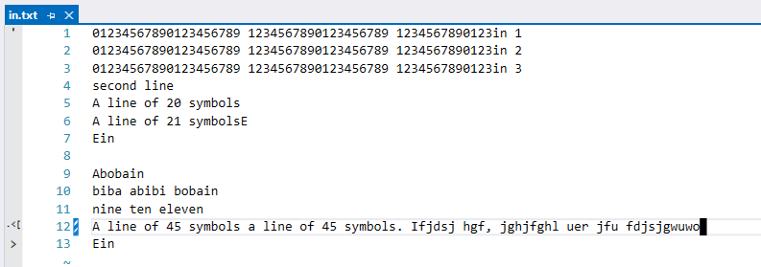

console

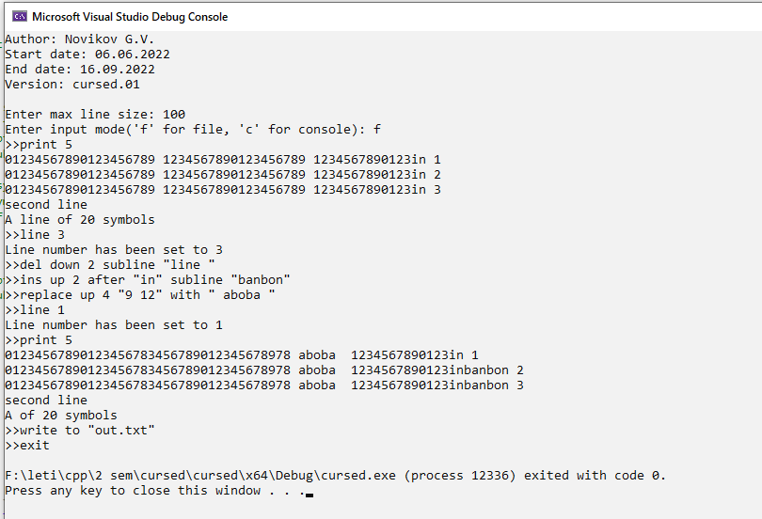

out.txt

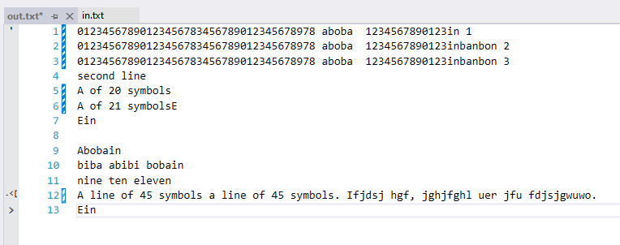

protocol.txt

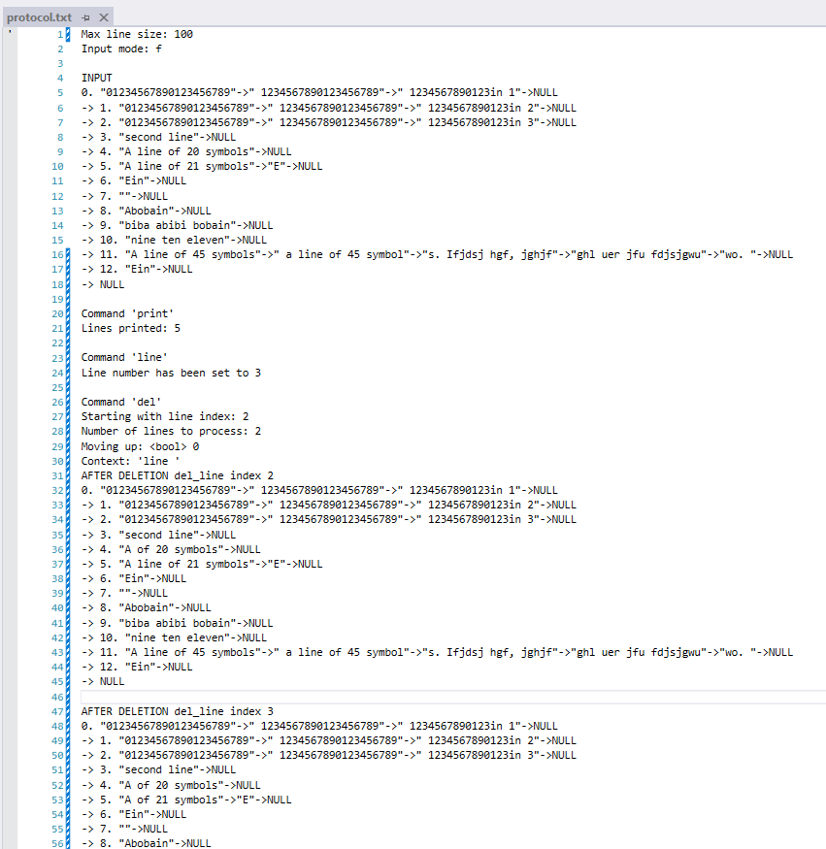

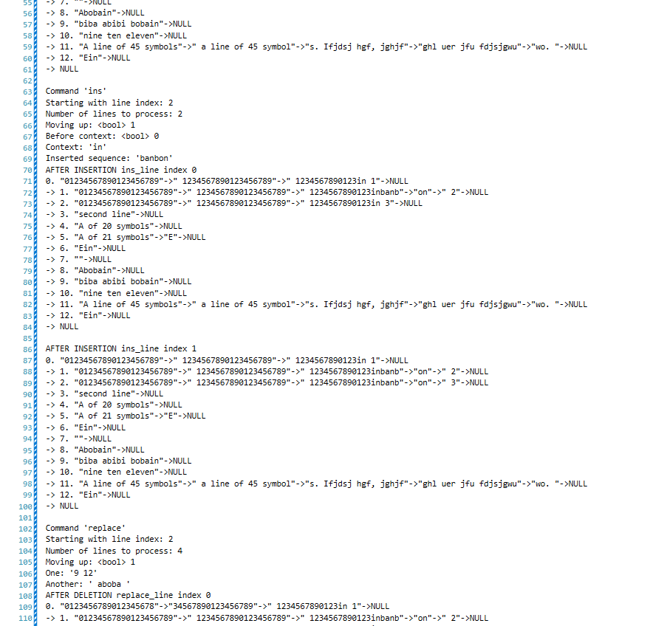

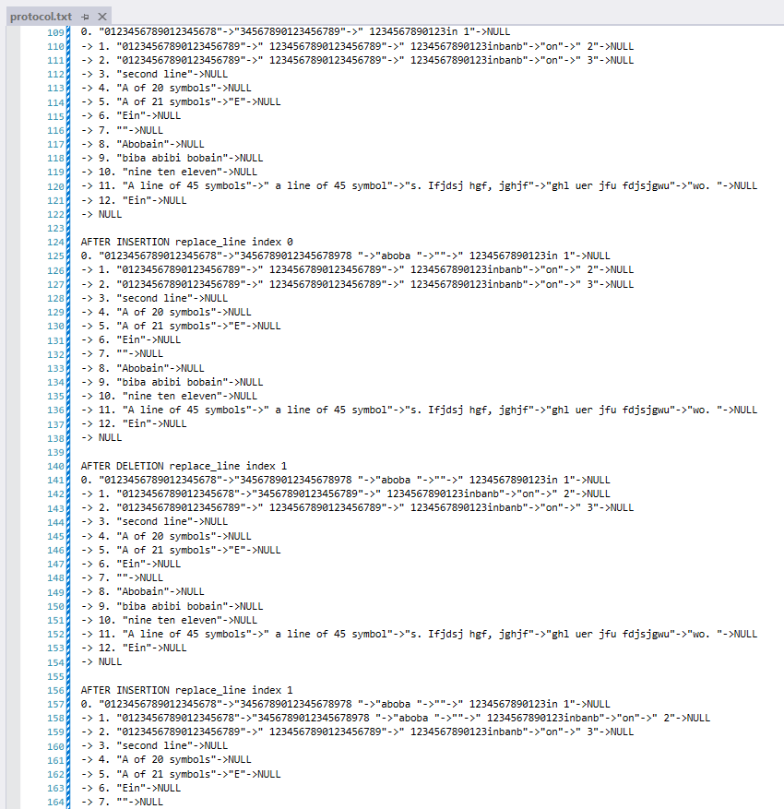

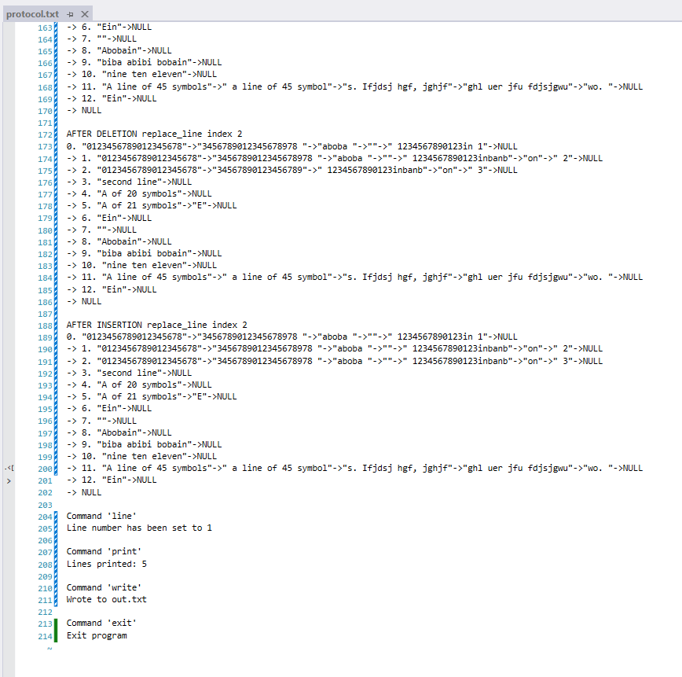

# Вывод

Цель работы выполнена, программа написана с достаточно удобным интерфейсом. В ходе написания программы были закреплены практические навыки программирования, обобщены знания синтаксиса языка, и продемонстрировано усвоение материала за второй семестр. Поставленная цель полностью соответствует полученному результату.